**UPDATING BLA CHECKOUT LOG**

Bi-Weekly/Monthly Task – depends on how many things are in the BLA folder

OPEN - BLA Check Out Log Sheet

G:\Clerical\Seg Dept\BLA1

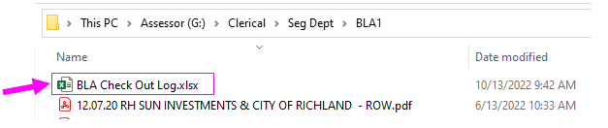

When clerical team transfers deeds: they will save documents for BLA, ROW, SALE of NEW Lots for Pending Plats, or even any deeds they are not sure about.

Those files will be saved here: G:\Clerical\Deed Technician\BLA

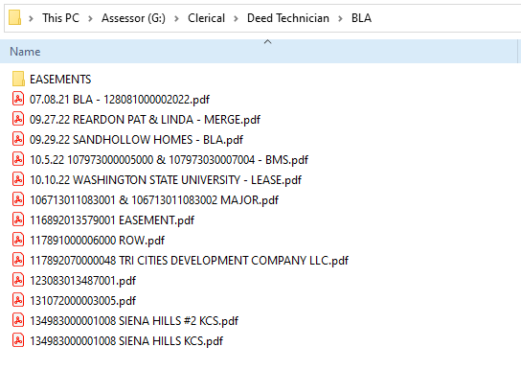  
Go through all of these deeds and decide **WHAT** they are and then follow the steps below.

**NOTE: anything that is changing land boundary needs to be drawn by Segregation Team 1st before we process those deeds.**

1. **BLA: (PAGE 2-5)** If you need help figuring out if the deed is BLA (see documentG:\Clerical\Deed Technician\Procedures – “How to Tell BLA DEED from regular deed”
2. **BSP (PAGE 6)**
3. **EASEMENT (PAGE 7-9)**
4. **ROW/EMINENT DOMAIN (PAGE 10-11)**
5. **SALE** of lots for pending BLA/NEW PLAT/SHORT PLAT **(PAGE 11)**
6. **SHORT PLATS (PAGE 11)**
7. **LONG PLATS (PAGE 12-13)**
8. **MISC (PAGE 14+)**
9. **BLA/MERGE**

Rename the file to read:   
BLA – DATE OF DEED - OWNERS  


Pull up all the parcels in PACS to check for: codes and potential issues with this bla.

All parcels to have group code “Pending BLA” 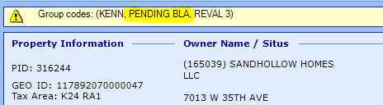

Make sure all the deeds are included in one packet. (Usually, BLA has multiple deeds. The way you can tell the deed is missing is by AF # is out of order, and/or legal descriptions. If all the deeds are not included, GIS won’t be able to complete the drawing.   
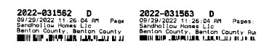

For example, this BLA has only two deeds. One of them is **includin**g portion and other deed is **excepting** portion.   
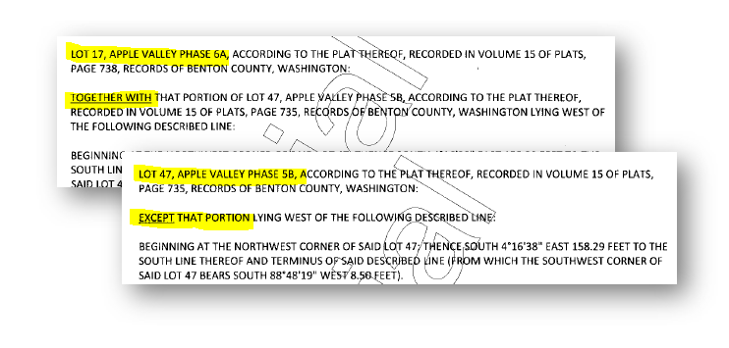

EXAMPLE #2 BLA WITH 3 DEEDs:

**DEED #1 – transfer portion from one parcel is the next door parcel.**  
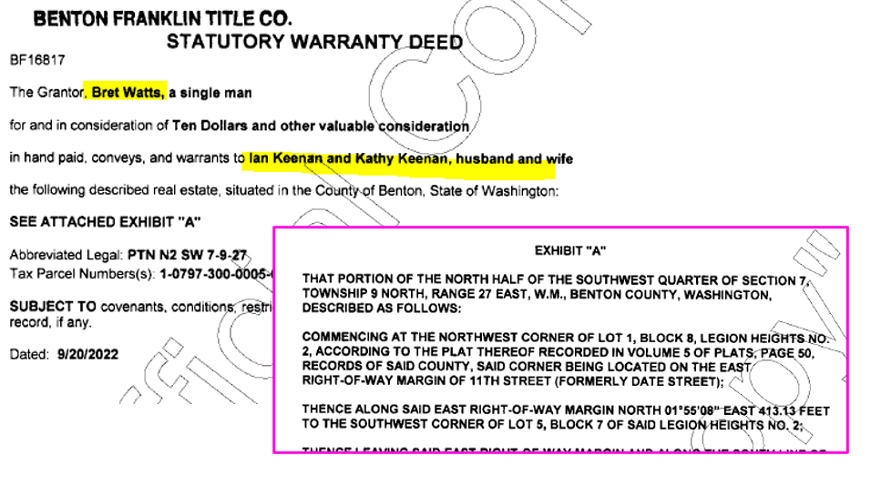 **DEED #2 – legal description of final boundary after the portion is transferred. – “together with” – in the legal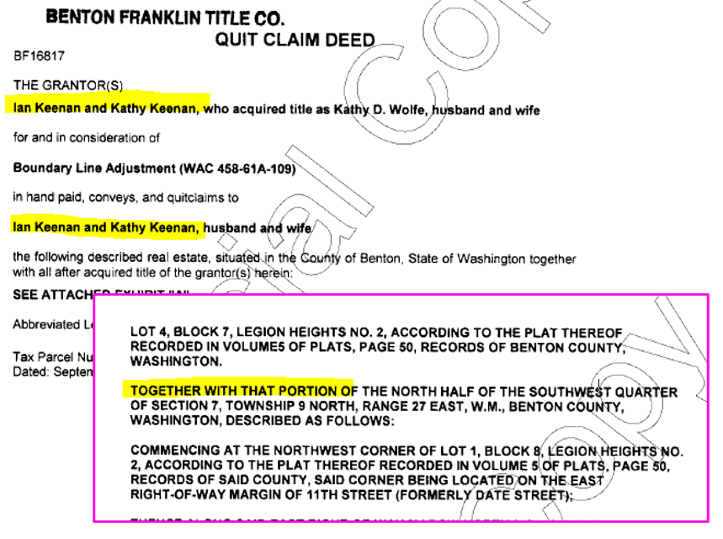 DEED #3 – legal description of final boundary after the portion is transferred. – “except” – in the legal**

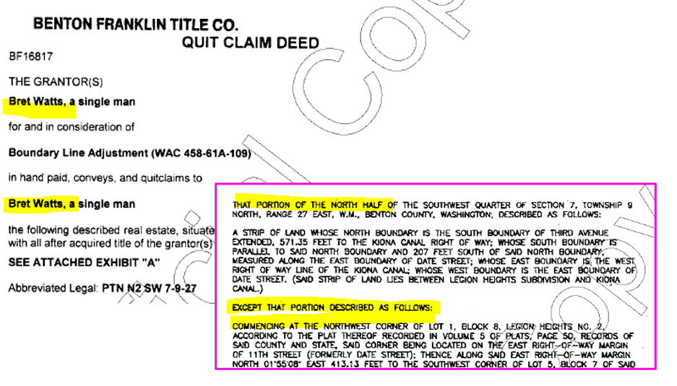

* While reviewing legal descriptions: Look for verbiage if this BLA has a supporting survey map: usually at the end they will reference a Survey Number. If it refences any, you can add to the “Notes/Comments” column in the spread sheet.  
   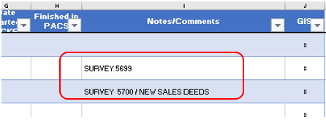

---this lets us know that there is a survey with this BLA:

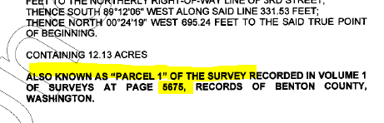

* Pull up the parcels in [**GIS-Seg map**](https://bentonco.maps.arcgis.com/apps/webappviewer/index.html?id=bbdac7e400a24c6e87110c2f8c559a73). Checking if this is 2nd BLA, or correction, also to get familiar with a map and where this BLA is. (in a later step you will pull surveys and it will help you to recognize which survey will go with this BLA, surveys don’t have parcel # on them)
* Add this BLA to the ***BLA Check Out Log.xlsx*** file***.***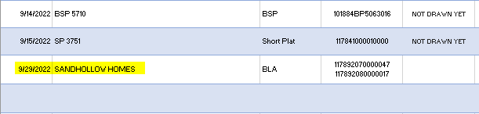
* Create Folder (including prep sheet, check list, survey (**from W drive), before and after map, deeds) & Move this Folder to: G:\Clerical\Seg Dept\BLA1 (once its drawn this is where you will grab this file to prep the BLA.
* PULLING UP THE SURVEY: after you are done adding all the BLA’s. Now you will search for SURVEYS that are recorded to support this BLA.   
  ***search surveys on the auditors website:***
* 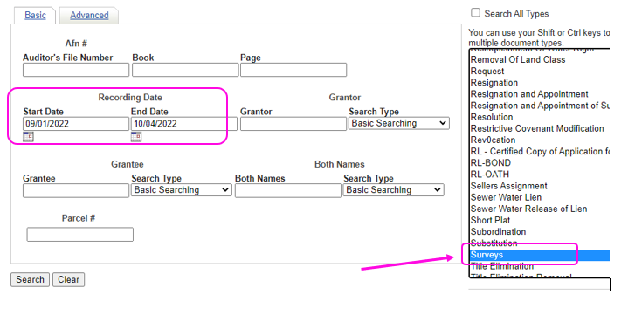

***Once you pull up the results like this picture below:*** Look through the last names that you might recognize from the BLA check list that you just created on the spreadsheet. (not all of them are filed under last name)   
  
Download the file and review surveys and see if there are any that you recognize based on the GIS map that you pulled up earlier to review the map… that might go with bla deeds.

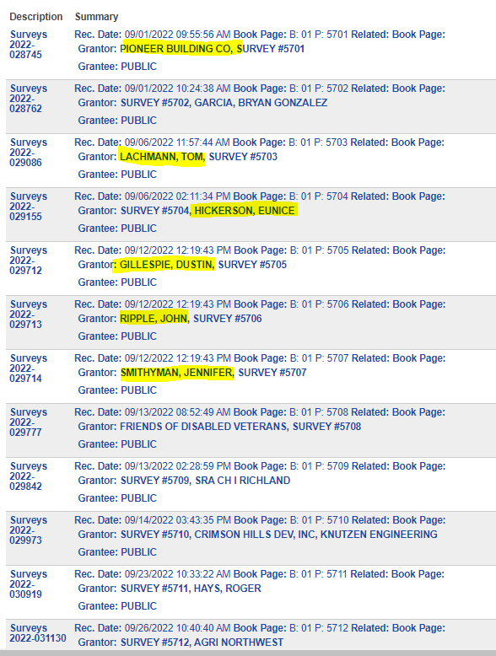

**NOTE:** That some surveys are recorded months in advanced and deeds are filed later. Usually, I (Liliya) search one month-two months for recording date just in case now I have the BLA deeds from prev month survey recordings. If you found any surveys that go along with current BLA – ADD them under “Notes/Comments” on the spread sheet.

Not all surveys are recorded for BLA, some are just for the record of it.

Also, look for Binding Site Plan (Auditor’s office indexes them under survey’s) See next step below.

***Done! With BLA’s  
____________________________________***

1. **BSP:** while reviewing recorded surveys. Look for **Binding Site Plan**  
   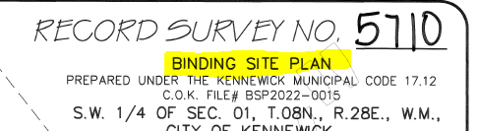

* Look for a parcel on the map for this BSP, usually there is none. Look up by the address in GIS map to identify where this BSP is taking place.

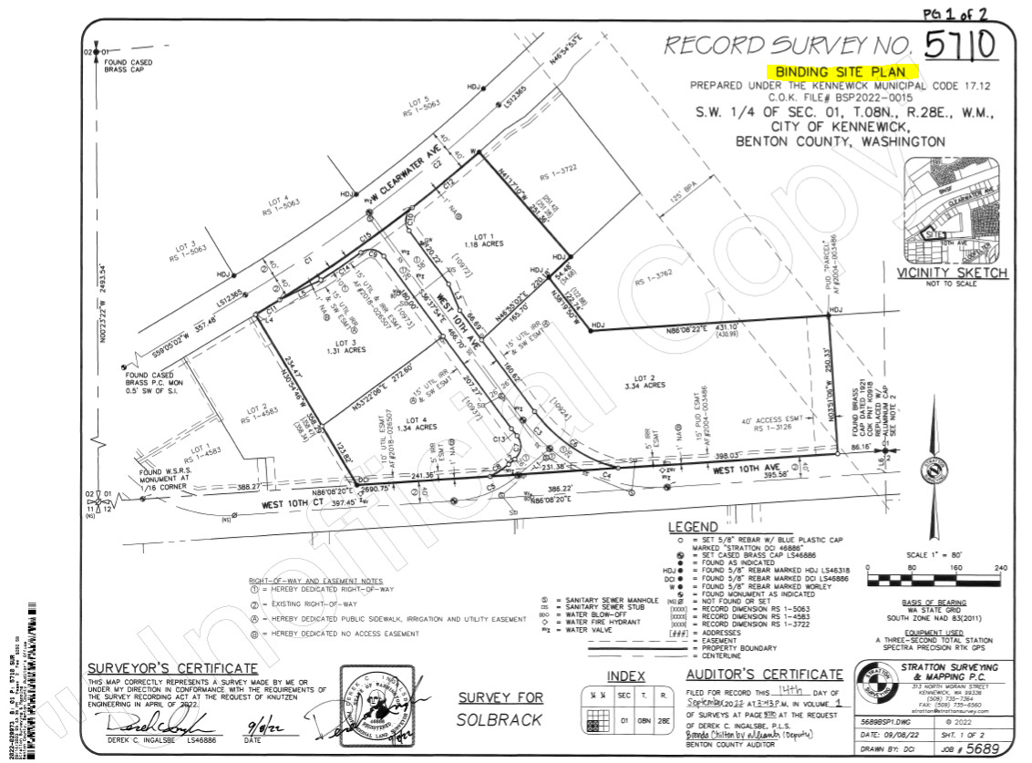

* Once you find the parcel(s). Open parcel in PACS. Add Group code as “Pending BLA”  
  Check if any BLA pending and such that needs to be done 1st (make notes on the spreadsheet if any)  
  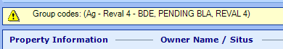
* Add this Property to BLA Check Out Log.
* You don’t need to move any files: when its ready you will go to W:Drive and search by SXXXX for this survey.
* Make a folder in BLA1 (name: BSP #### OR #### SP), add appropriate prep sheets and supporting documents.

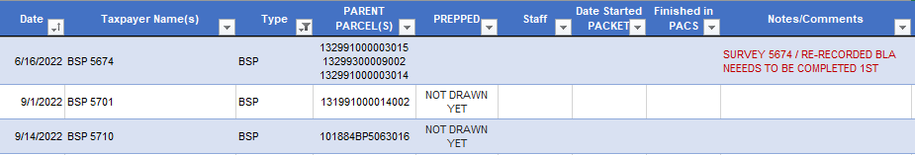

***Done! With BSP’s.  
________________________________***

YOU ARE DOING A GREAT JOB! At exactly this moment! Keep Going! 😊

1. **EASEMENT –** Read FULL deed and see if this is Eminent Domain or Easement.

We don’t adjust boundaries for Easements. Easements are created by/for Utility Departments,   
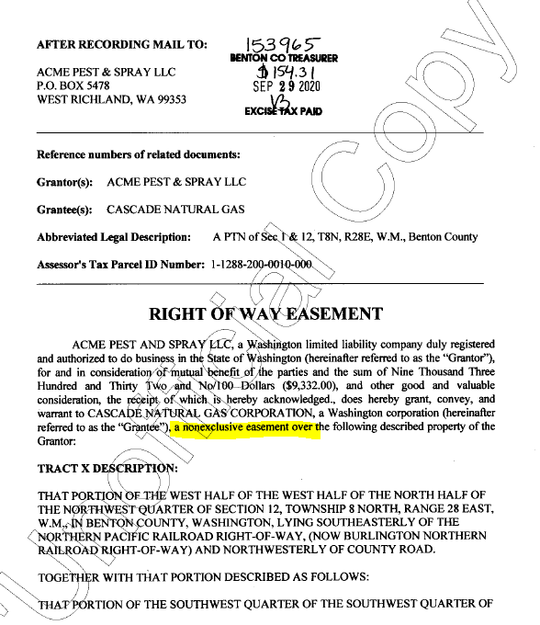

* Transfer the Deed: Leave Comments in the transfer, set the taxpayer back.

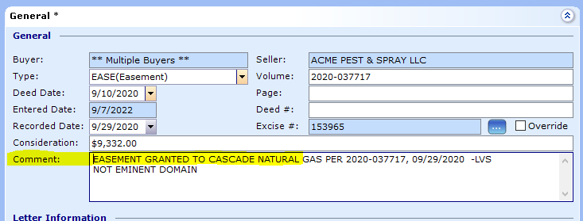

* Update legal description.

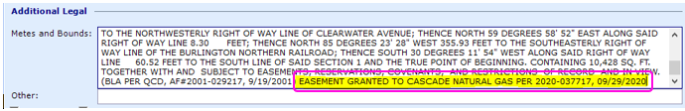

Examples of Easements:

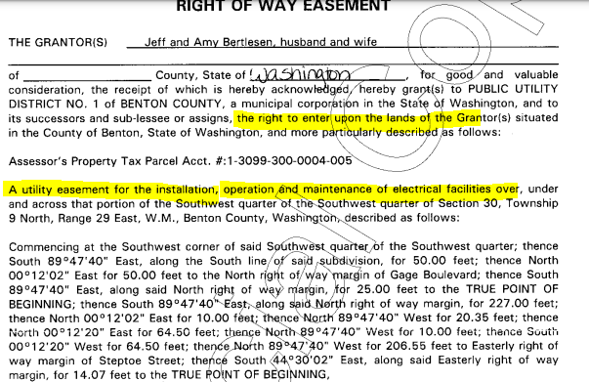

You will read into these documents and find out that its access easement only (see full deed 2022-019239)

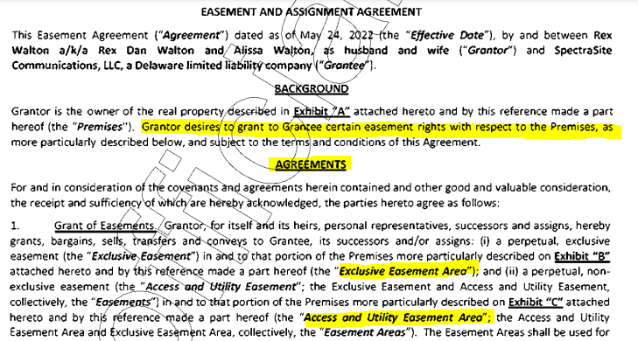

**You can transfer these deeds that have an excise or file them into the EASEMENT folder and the them later in your down time.  
Note: If Easement Deed doesn’t have an excise. Update the legal description only.**

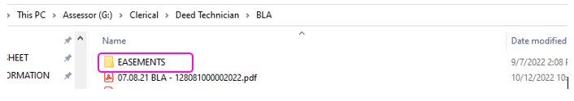

***Done! With EASEMENTS!  
________________________________***

1. **ROW/EMINENT DOMAIN – READ the whole deed. You will look for “Eminent Domain”, this means that portion of land is being taken away for the road, so we will need to do description change.**

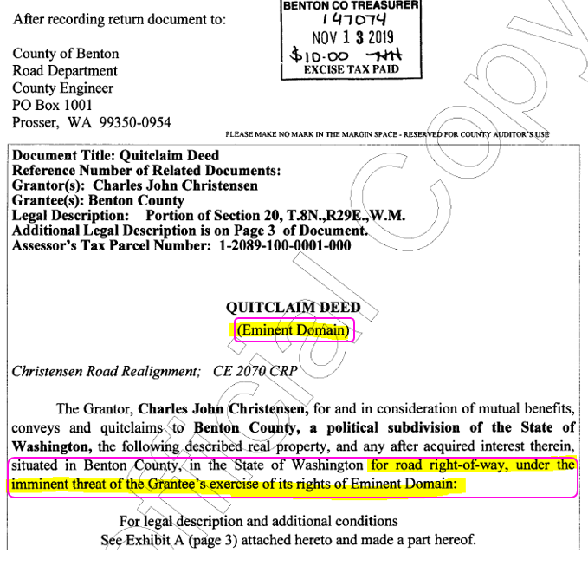

Usually, Eminent Domain will also have a sale $$$ for transfer of this land for the road purposes.

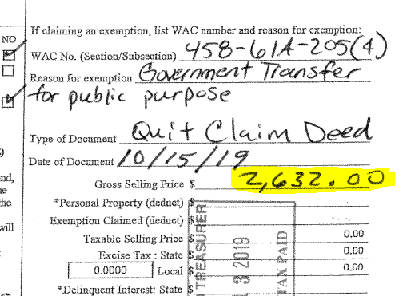

* Change the name of the PDF FILE to:

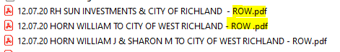

* Add to the spreadsheet to our log for this to be drawn/highlight them in green

(I don’t flag with group code for “pending bla” because it’s a small adj. and don’t want transfer of deed to be held up, especially when this is last on our priority list to process) BUT I could be wrong.

Add to the file (Z. ROW-E.D. MASTER), shapefile, before and after map, excel row-master copy and new description change letter

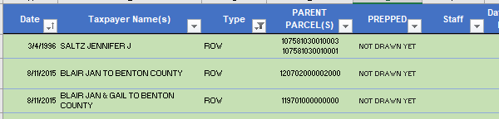

**DONE! With ROW!  
_______________________________________**

1. **SALE** of lots for pending BLA/NEW PLAT/SHORT PLAT   
   **BLA:** Check if there is folder already created for BLA: File there. If not created yet. Add this deed to the end of all the deeds, that is pending for BLA. (do this in Adobe PDF Creator >> Tools >>> Combine Files >> Save As.  
   **SP/BSP/LONG PLAT:** If folder is not created yet. Create a Folder and File there.

____________________________________

1. **SHORT PLATS:**   
   Check on the spreadsheet when last SP was documented: The SP# is always recorded in numerical order.

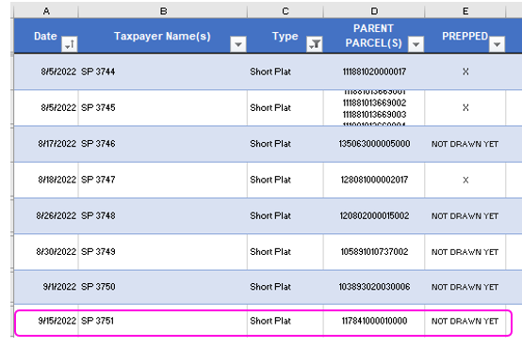

* Search on Auditor’s Website from the date range to current date:

*In this Case*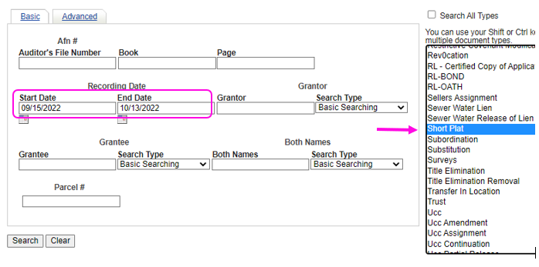

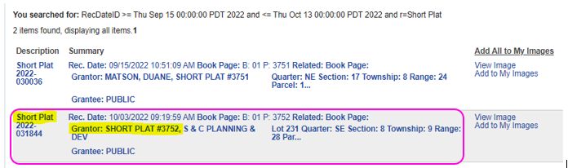

In this case SP 3751 is already on the list:

* You will need to add the next one **SP#3752**
* **Same Process as Binding Site Plan (See Page 6)**

**DONE! With Short Plats!**

**____________________________**

1. **LONG PLATS**

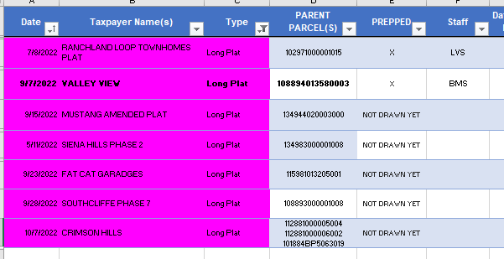

* Check when the last LONG PLAT was documented.
* Search Auditor’s Web: Select Date/Plats

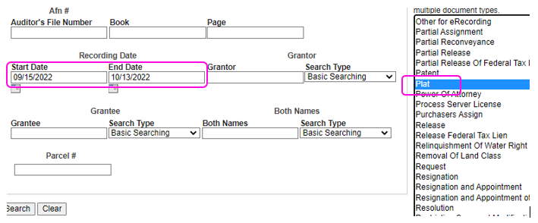

* Add if any most recent recorded Plats to the List.

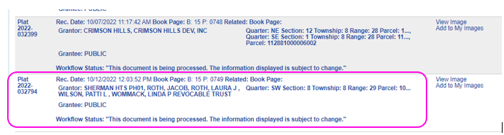

MISC.

* Some of the deeds that you might find – where deed tech is not sure what the is, below are some examples. Always read the **WHOLE** deed and see what they are trying to do.

Example this deed: has an excise. This deed is clearing title only. No transfer of land.   
Steps to follow:   
**Set** the grantor as KIONA IRRIGATION DISTRICT.   
**Transfer** this deed, leave comments.   
**Set** the Taxpayer back to the owner. DONE!